**CASH DEPOSIT MACHINE**

Cash Deposit Machine (CDM) is a self-service terminal that enables you to deposit cash without any manual intervention of branch officer. We can also withdraw the amount and check for balance amount which can also be used as an ATM machine.

**SOFTWARE USED:** EMU 8086 (.EXE FILE)

**FLOW CHART:**

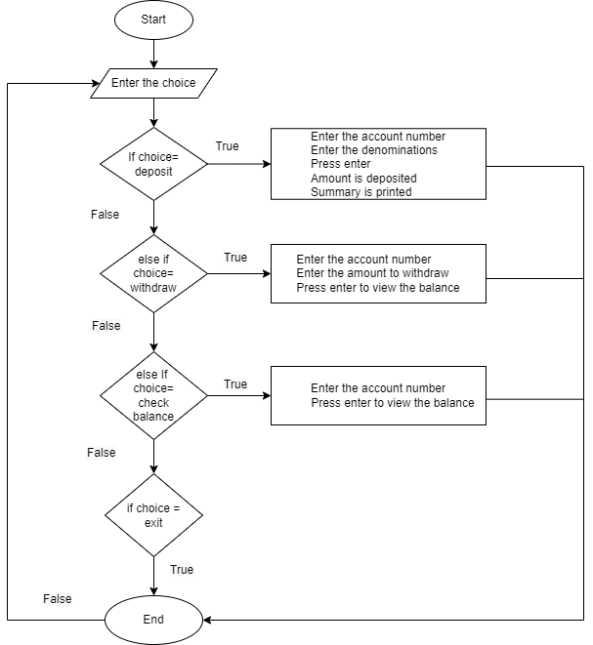

**PSEDO CODE:**

1. If choice=deposit

Enter the account number

Enter the amount to deposit

Enter the denominations

Press enter to deposit the amount and print the summary

1. Else If choice=withdraw

Enter the account number

Enter the amount to withdraw

Press enter to withdraw the amount

1. Else If choice=Check balance

Enter the account number

Press enter to view the balance

1. Else If choice=Exit

Program ends

**INPUT AND OUPUT:**

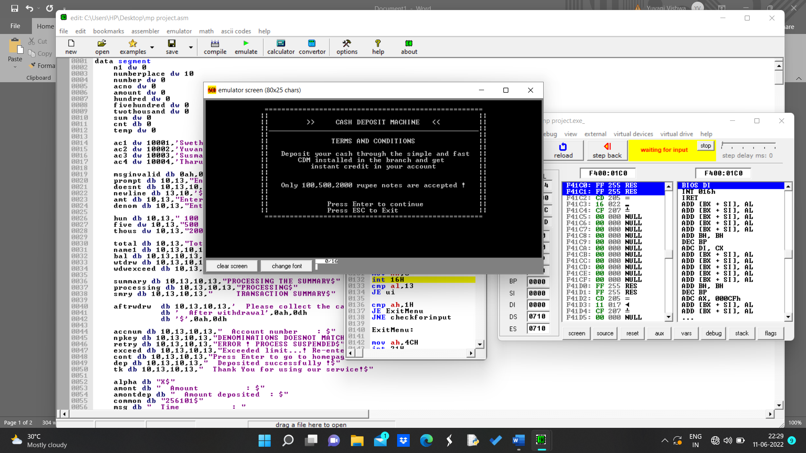

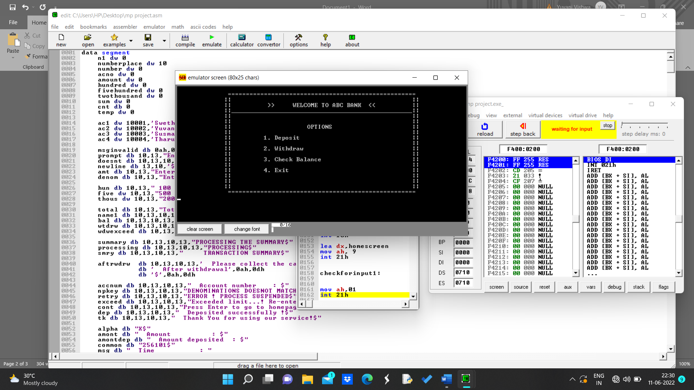

**To check balance :**

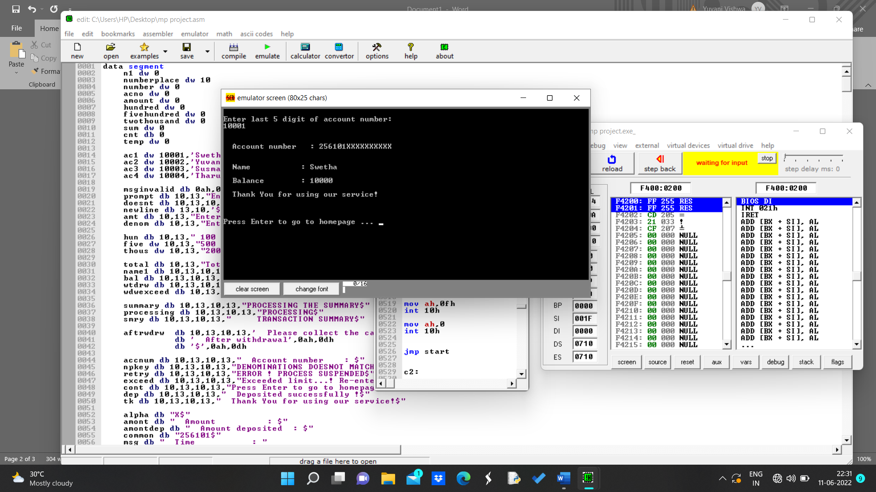

**To withdraw the amount :**

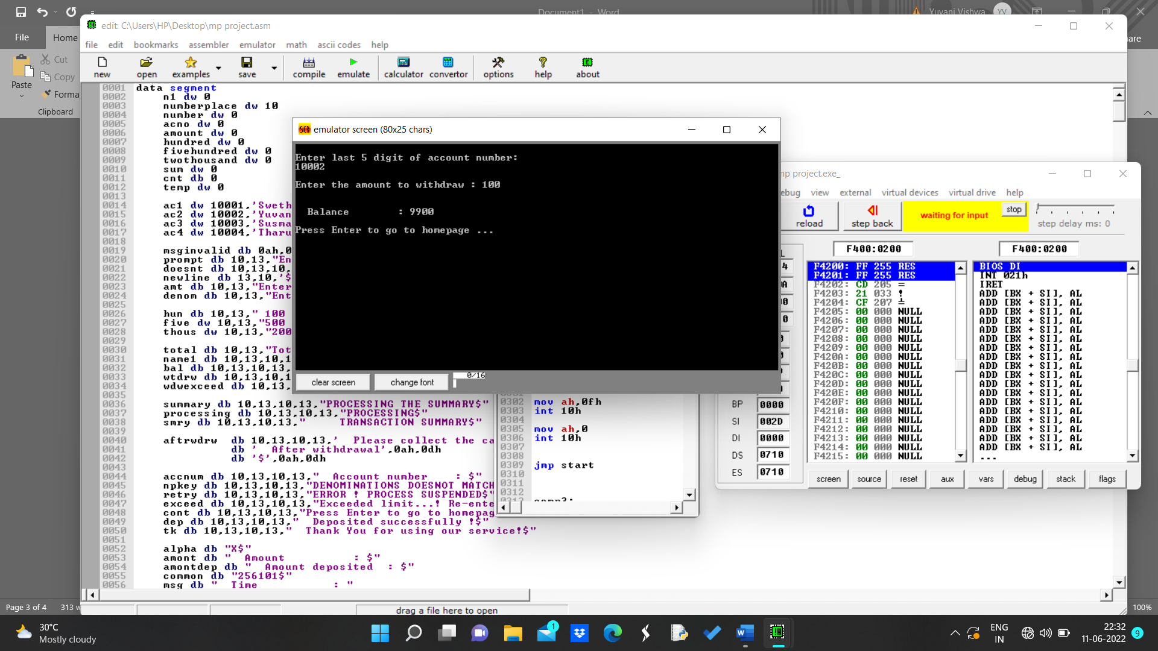

**To deposit the amount:**

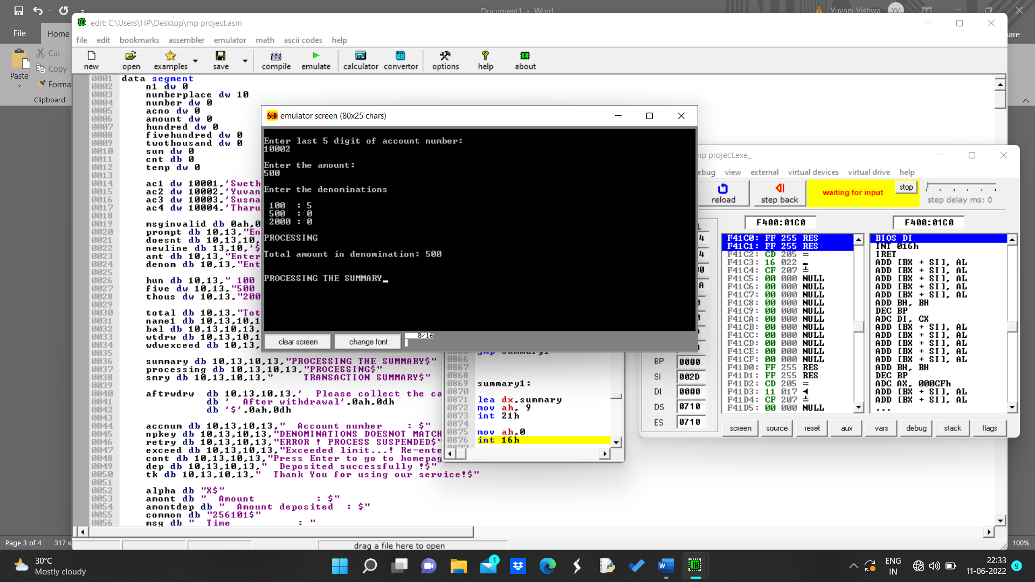

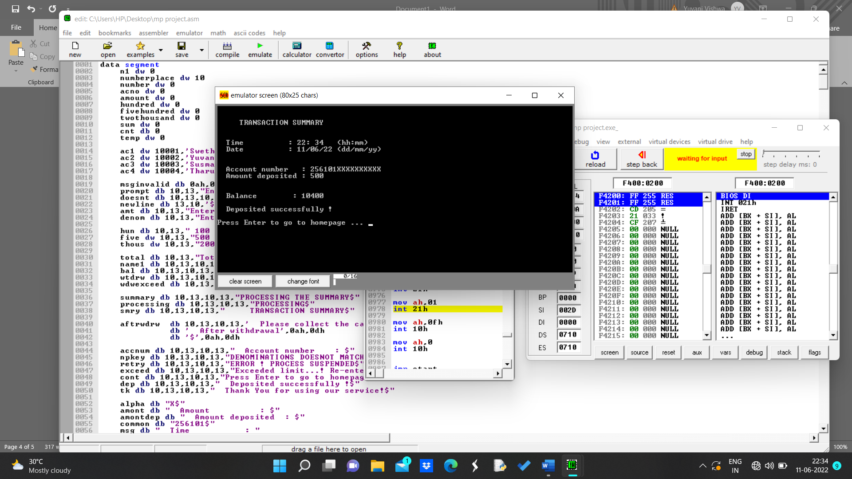

**Mismatch of entered amount and denominations :**

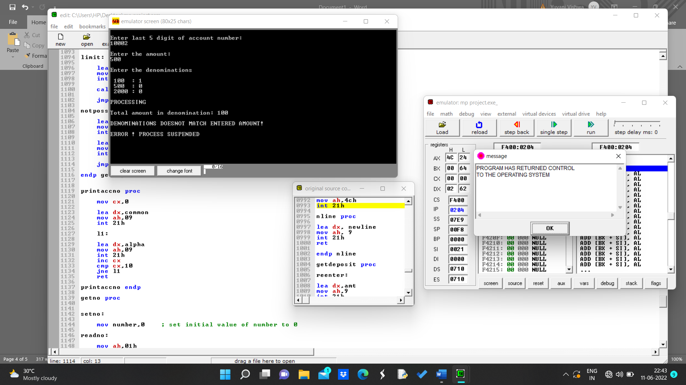

**Invalid inputs :**

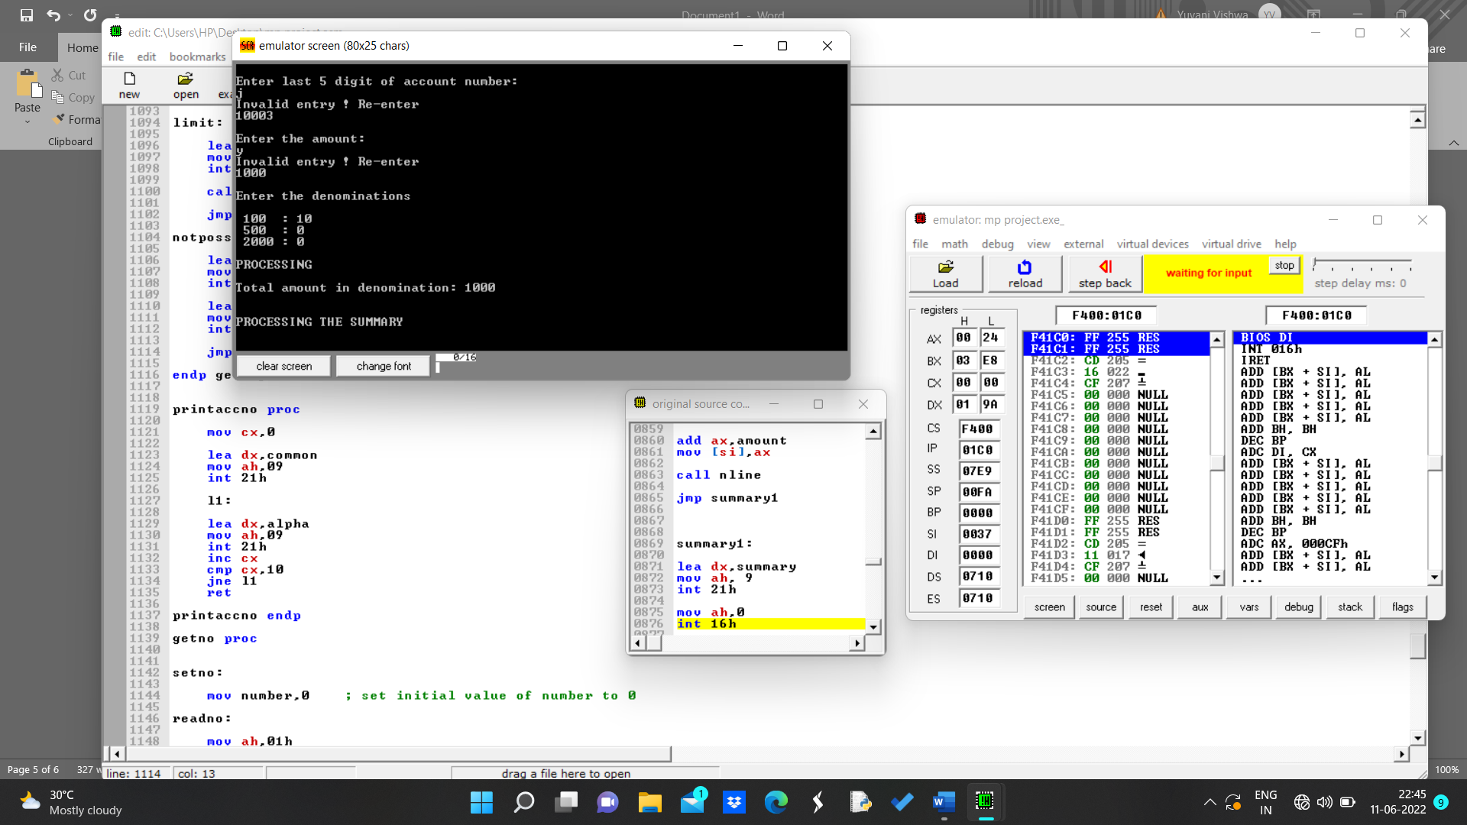

**Points to be noted!**

* You need to be an account holder in order to do the operations.
* A maximum of 50000 can be deposited.
* A receipt will be generated giving all details of amount deposited like account number, name, total amount.
* If you are the account holder you can do balance enquiry and you can also withdraw the amount.

**Process :**

* First enter the last 5 digits of your account number.
* Select from the given options (Deposit, Withdraw, Check balance)
* To check the balance, just enter the account number again balance amount will be displayed with the account holder name.
* To withdraw, enter the amount and the amount will be deducted from the main balance.
* To deposit, enter the amount followed by denomination if both are equal amount will be deposited and receipt will be generated else it returns to homepage.